BigQuery: Qwik Start - Command Line

30 minutesFree

**GSP071**



**Overview**

Storing and querying massive datasets can be time consuming and expensive without the right hardware and infrastructure. BigQuery is a serverless, highly scalable [cloud data warehouse](https://cloud.google.com/solutions/bigquery-data-warehouse) that solves this problem by enabling super-fast SQL queries using the processing power of Google's infrastructure. Simply move your data into BigQuery and let us handle the hard work. You can control access to both the project and your data based on your business needs, such as giving others the ability to view or query your data.

You can access BigQuery by using the [Console](https://cloud.google.com/bigquery/docs/quickstarts/quickstart-web-ui), [Web UI](https://console.cloud.google.com/bigquery?utm_source=bqui&utm_medium=link&utm_campaign=classic&project=cloud-solutions-group) or a [command-line tool](https://cloud.google.com/bigquery/docs/cli_tool) using a variety of [client libraries](https://cloud.google.com/bigquery/docs/reference/libraries) such as Java, .NET, or Python. There are also a variety of [solution providers](https://cloud.google.com/bigquery/providers) that you can use to interact with BigQuery.

This hands-on lab shows you how to use bq, the python-based command line tool for BigQuery, to query public tables and load sample data into BigQuery.

**Setup and Requirements**

**Before you click the Start Lab button**

Read these instructions. Labs are timed and you cannot pause them. The timer, which starts when you click **Start Lab**, shows how long Google Cloud resources will be made available to you.

This hands-on lab lets you do the lab activities yourself in a real cloud environment, not in a simulation or demo environment. It does so by giving you new, temporary credentials that you use to sign in and access Google Cloud for the duration of the lab.

To complete this lab, you need:

* Access to a standard internet browser (Chrome browser recommended).

\_\_Note:\_\_ Use an Incognito or private browser window to run this lab. This prevents any conflicts between your personal account and the Student account, which may cause extra charges incurred to your personal account.

* Time to complete the lab---remember, once you start, you cannot pause a lab.

\_\_Note:\_\_ If you already have your own personal Google Cloud account or project, do not use it for this lab to avoid extra charges to your account.

**How to start your lab and sign in to the Google Cloud Console**

1. Click the **Start Lab** button. If you need to pay for the lab, a pop-up opens for you to select your payment method. On the left is a panel populated with the temporary credentials that you must use for this lab.

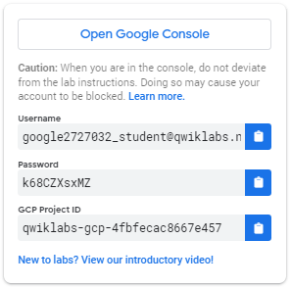

1. Copy the username, and then click **Open Google Console**. The lab spins up resources, and then opens another tab that shows the **Sign in** page.

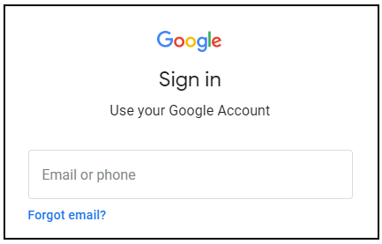

***Tip:*** Open the tabs in separate windows, side-by-side.

If you see the **Choose an account** page, click **Use Another Account**. 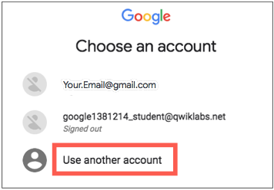

1. In the **Sign in** page, paste the username that you copied from the left panel. Then copy and paste the password.

***Important:*** You must use the credentials from the left panel. Do not use your Google Cloud Training credentials. If you have your own Google Cloud account, do not use it for this lab (avoids incurring charges).

1. Click through the subsequent pages:
   * Accept the terms and conditions.
   * Do not add recovery options or two-factor authentication (because this is a temporary account).
   * Do not sign up for free trials.

After a few moments, the Cloud Console opens in this tab.

**Note:** You can view the menu with a list of Google Cloud Products and Services by clicking the **Navigation menu** at the top-left. 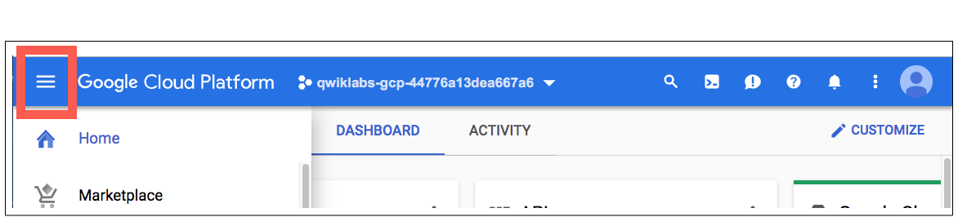

Activate Cloud Shell

Cloud Shell is a virtual machine that is loaded with development tools. It offers a persistent 5GB home directory and runs on the Google Cloud. Cloud Shell provides command-line access to your Google Cloud resources.

In the Cloud Console, in the top right toolbar, click the **Activate Cloud Shell** button.

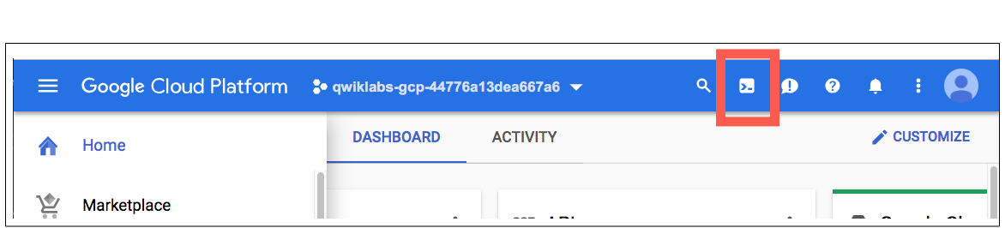

Click **Continue**.

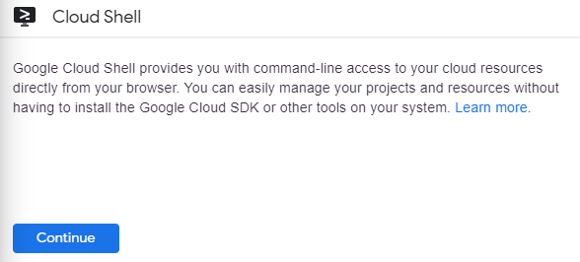

It takes a few moments to provision and connect to the environment. When you are connected, you are already authenticated, and the project is set to your *PROJECT\_ID*. For example:

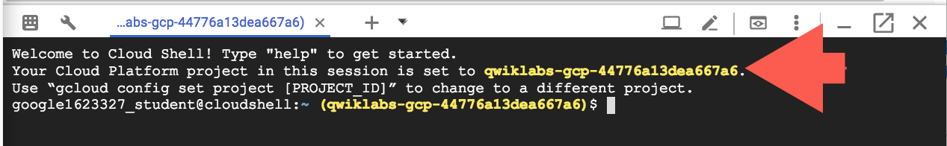

gcloud is the command-line tool for Google Cloud. It comes pre-installed on Cloud Shell and supports tab-completion.

You can list the active account name with this command:

gcloud auth list

Copied!

content\_copy

(Output)

ACTIVE: \*

ACCOUNT: student-01-xxxxxxxxxxxx@qwiklabs.net

To set the active account, run:

$ gcloud config set account `ACCOUNT`

You can list the project ID with this command:

gcloud config list project

Copied!

content\_copy

(Output)

[core]

project = <project\_ID>

(Example output)

[core]

project = qwiklabs-gcp-44776a13dea667a6

For full documentation of gcloud see the [gcloud command-line tool overview](https://cloud.google.com/sdk/gcloud" \t "_blank).

**Examine a table**

[**https://cloud.google.com/bigquery/public-data#sample\_tables**](https://cloud.google.com/bigquery/public-data#sample_tables)

BigQuery offers a number of [sample tables](https://cloud.google.com/bigquery/public-data#sample_tables) that you can run queries against. In this lab, you'll run queries against the shakespeare table, which contains an entry for every word in every play.

To examine the schema of the Shakespeare table in the samples dataset, run:

bq show bigquery-public-data:samples.shakespeare

Copied!

content\_copy

In this command you're doing the following:

* bq to invoke the BigQuery command line tool
* show is the action
* then you're listing the name of the project:public dataset.table in BigQuery that you want to see.

Output:

Last modified Schema Total Rows Total Bytes Expiration Time Partitioning Clustered Fields Labels

----------------- ------------------------------------ ------------ ------------- ------------ ------------------- ------------------ --------

14 Mar 13:16:45 |- word: string (required) 164656 6432064

|- word\_count: integer (required)

|- corpus: string (required)

|- corpus\_date: integer (required)

**Run the help command**

When you include a command name with the help commands, you get information about that specific command. For example, the following call to bq help retrieves information about the query command.

bq help query

Copied!

content\_copy

To see a list of all of the commands bq uses, run just bq help.

**Run a query**

Now you'll run a query to see how many times the substring "raisin" appears in Shakespeare's works.

To run a query, run the command bq query "[SQL\_STATEMENT]".

* Escape any quotation marks inside the [SQL\_STATEMENT] with a \ mark, or
* Use a different quotation mark type than the surrounding marks ("versus").

Run the following standard SQL query in Cloud Shell to count the number of times that the substring "raisin" appears in all of Shakespeare's works:

bq query --use\_legacy\_sql=false \

'SELECT

word,

SUM(word\_count) AS count

FROM

`bigquery-public-data`.samples.shakespeare

WHERE

word LIKE "%raisin%"

GROUP BY

word'

Copied!

content\_copy

In this command:

* --use\_legacy\_sql=false makes standard SQL the default query syntax

Output:

Waiting on job\_e19 ... (0s) Current status: DONE

+---------------+-------+

| word | count |

+---------------+-------+

| praising | 8 |

| Praising | 4 |

| raising | 5 |

| dispraising | 2 |

| dispraisingly | 1 |

| raisins | 1 |

The table demonstrates that although the actual word **raisin** doesn't appear, the letters appear in order in several of Shakespeare's works.

**Test Completed Task**

Click **Check my progress** to verify your performed task. If you have successfully run query against public dataset, you will see an assessment score.

Run a query (dataset: samples, table: shakespeare, substring: raisin)

Check my progress

If you search for a word that isn't in Shakespeare's works, no results are returned.

Run following search for "huzzah", returns no matches:

bq query --use\_legacy\_sql=false \

'SELECT

word

FROM

`bigquery-public-data`.samples.shakespeare

WHERE

word = "huzzah"'

Copied!

content\_copy

**Test Completed Task**

Click **Check my progress** to verify your performed task. If you have successfully run query against public dataset, you will see an assessment score.

Run a query (dataset: samples, table: shakespeare, substring: huzzah)

Check my progress

**Create a new table**

Now create your own table. Every table is stored inside a dataset. A *dataset* is a group of resources, such as tables and views.

**Create a new dataset**

Use the bq ls command to list any existing datasets in your project:

bq ls

Copied!

content\_copy

You will be brought back to the command line since there aren't any datasets in your project yet.

Run bq ls and the bigquery-public-data Project ID to list the datasets in that specific project, followed by a colon (:).

bq ls bigquery-public-data:

Copied!

content\_copy

Output:

datasetId

-----------------------------

austin\_311

austin\_bikeshare

austin\_crime

austin\_incidents

austin\_waste

baseball

bitcoin\_blockchain

bls

census\_bureau\_construction

census\_bureau\_international

census\_bureau\_usa

census\_utility

chicago\_crime

...

Now create a dataset. A dataset name can be up to 1,024 characters long, and consist of A-Z, a-z, 0-9, and the underscore, but it cannot start with a number or underscore, or have spaces.

Use the bq mk command to create a new dataset named babynames in your Qwiklabs project:

bq mk babynames

Copied!

content\_copy

Sample output:

Dataset 'qwiklabs-gcp-ba3466847fe3cec0:babynames' successfully created.

**Test Completed Task**

Click **Check my progress** to verify your performed task. If you have successfully created BigQuery dataset with name as babynames, you will see an assessment score.

Create a new dataset (name: babynames)

Check my progress

Run bq ls to confirm that the dataset now appears as part of your project:

bq ls

Copied!

content\_copy

Sample output:

datasetId

-------------

babynames

**Upload the dataset**

Before you can build the table, you need to add the dataset to your project. The custom data file you'll use contains approximately 7 MB of data about popular baby names, provided by the US Social Security Administration.

Run this command to add the [baby names zip file](http://www.ssa.gov/OACT/babynames/names.zip) to your project, using the URL for the data file:

curl -LO http://www.ssa.gov/OACT/babynames/names.zip

Copied!

content\_copy

List the file:

ls

Copied!

content\_copy

You can see the name of the file added to your project.

Now unzip the file:

unzip names.zip

Copied!

content\_copy

That's a pretty big list of text files! List the files again:

ls

Copied!

content\_copy

The bq load command creates or updates a table and loads data in a single step.

You will use the bq load command to load your source file into a new table called names2010 in the babynames dataset you just created. By default, this runs synchronously, and will take a few seconds to complete.

The bq load arguments you'll be running are:

datasetID: babynames

tableID: names2010

source: yob2010.txt

schema: name:string,gender:string,count:integer

Create your table:

bq load babynames.names2010 yob2010.txt name:string,gender:string,count:integer

Copied!

content\_copy

Sample output:

Waiting on job\_4f0c0878f6184119abfdae05f5194e65 ... (35s) Current status: DONE

**Test Completed Task**

Click **Check my progress** to verify your performed task. If you have successfully load data into dataset table, you will see an assessment score.

Load the data into a new table

Check my progress

Run bq ls and babynames to confirm that the table now appears in your dataset:

bq ls babynames

Copied!

content\_copy

Output:

tableId Type

----------- -------

names2010 TABLE

Run bq show and your dataset.table to see the schema:

bq show babynames.names2010

Copied!

content\_copy

Output:

Last modified Schema Total Rows Total Bytes Expiration Time Partitioning Clustered Fields Labels

----------------- ------------------- ------------ ------------- ----------------- ------------------- ------------------ --------

13 Aug 14:37:34 |- name: string 34073 654482 12 Oct 14:37:34

|- gender: string

|- count: integer

By default, when you load data, BigQuery expects UTF-8 encoded data. If you have data that is in ISO-8859-1 (or Latin-1) encoding and are having problems with your loaded data, you can tell BigQuery to treat your data as Latin-1 explicitly, using the -E flag. For more information, see [Character Encodings](https://cloud.google.com/bigquery/docs/loading-data).

**Run queries**

Now you're ready to query the data and return some interesting results.

Run the following command to return the top 5 most popular girls names:

bq query "SELECT name,count FROM babynames.names2010 WHERE gender = 'F' ORDER BY count DESC LIMIT 5"

Copied!

content\_copy

Output:

Waiting on job\_58c0f5ca52764ef1902eba611b71c651 ... (0s) Current status: DONE

+----------+-------+

| name | count |

+----------+-------+

| Isabella | 22913 |

| Sophia | 20643 |

| Emma | 17345 |

| Olivia | 17028 |

| Ava | 15433 |

+----------+-------+

Run the following command to see the top 5 most unusual boys names.

bq query "SELECT name,count FROM babynames.names2010 WHERE gender = 'M' ORDER BY count ASC LIMIT 5"

Copied!

content\_copy

**Note**: The minimum count is 5 because the source data omits names with fewer than 5 occurrences.

Output:

Waiting on job\_556ba2e5aad340a7b2818c3e3280b7a3 ... (1s) Current status: DONE

+----------+-------+

| name | count |

+----------+-------+

| Aaqib | 5 |

| Aaidan | 5 |

| Aadhavan | 5 |

| Aarian | 5 |

| Aamarion | 5 |

+----------+-------+

**Test Completed Task**

Click **Check my progress** to verify your performed task. If you have successfully run query against custom dataset, you will see an assessment score.

Run queries against your dataset table

Check my progress

**Test your Understanding**

Below are multiple choice questions to reinforce your understanding of this lab's concepts. Answer them to the best of your abilities.

You can access BigQuery using:



Command line tool



Web UI



GStreamer



GLib



BigQuery REST API

Submit

Which CLI tool is used to interact with BigQuery service?



gsutil



compute



bq



gcloud

Submit

**Clean up**

Run the bq rm command to remove the babynames dataset with the -r flag to delete all tables in the dataset.

bq rm -r babynames

Copied!

content\_copy

Confirm the delete command by typing Y.

**Test Completed Task**

Click **Check my progress** to verify your performed task. If you have successfully removed babynames dataset, you will see an assessment score.

Remove the babynames dataset

Check my progress

**Congratulations!**

<https://cloud.google.com/sdk/gcloud>

